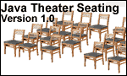
JAVA THEATER SEATING LAB REPORT
Name and Student ID: Jibran Akhter - 1073973
Date project completed: 3/17/2024
Platform (Mac, PC, Linux, etc.): Windows 11 PC
Development system (onlineGDB, NetBeans, Eclipse): OnlineGDB

OBJECTIVES:
Use CONSTANT definitions for the price of each seat and tax rate
Use console input to read data from the keyboard using the Scanner's nextInt( ) method
Reject non-numeric and negative input values
Calculate a total value for seats sold, sales tax, service charge and total
Use console output to display total with 2 digits past the decimal for currency values (dollars and cents)

PROJECT DESCRIPTION:
The theater has three categories of seats and prices
1) $45.00 for the premium seats
2) $30.00 for the standard seats
3) $21.00 for the economy seats
Write a program that processes the sale of seats. Ask the user to input the number of seats sold for each category and computes the total for all seats sold. Add a sales tax of 8.25% to the total and then a $5.00 service charge.
The program is to use constant definitions for the price of each seat and reject non-integer and negative values input for the number of seats sold. The program outputs a subtotal for all seats sold, the sales tax, the service charge and the total for the sale. Tax, service charge and total are to be displayed using two digits past the decimal point.

INPUT – PROCESS – OUTPUT TABLE:
INPUTS | PROCESSING | OUTPUTS
Number of seats sold for Premium,
Standard and Economy

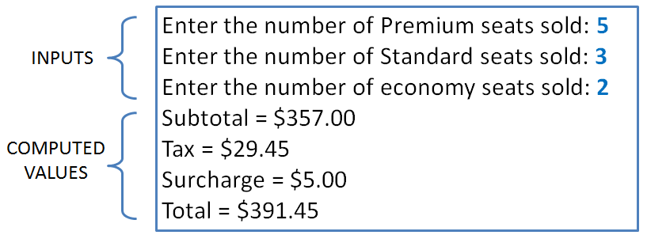
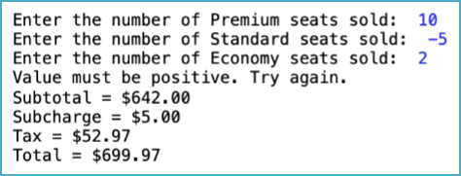
SAMPLE OUTPUTS:
Negative value input
Negative value input
Error
message

TEST DATA TABLE:
Fill in the Test Data Values and Expected Results as shown on the lab assignment.
*** You need to choose your test values and replace the ?? with your chosen test values ***
Fill in the Actual Results after you have run and tested your program
TEST DATA VALUES  Choose your test values. Replace each ?? with your choice | EXPECTED RESULT  Computed values before  the program is run | ACTUAL RESULT  Fill in the output displayed  by the program
premium = 20  standard = 30  economy = 50 | 3090.13 | 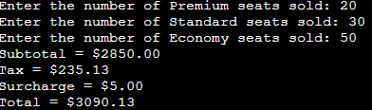
premium = 10  standard = -5  economy = 80 | 2586.76 | 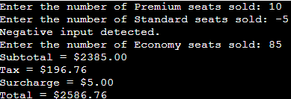
premium = 20  standard = five  economy = 45 | Invalid input | 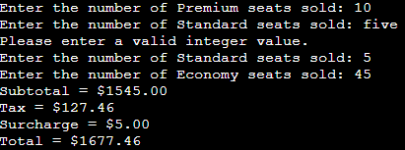

DISCUSSION:
What did you do to develop the program? ("Followed the Directions" is not a complete description
To create the program, I first set up the basic framework by defining the prices for different types of seats, along with the sales tax rate and service charge. Then, I wrote the main part of the program that guides the user through inputting the number of seats sold for each category: premium, standard, and economy. To ensure the user enters valid information, I built in checks to reject negative numbers and handle non-integer inputs gracefully. For negative inputs, I let the user know that I'm treating them as positive to maintain consistency. If the user accidentally types a letter instead of a number, I politely prompt them to enter a valid integer value. Once I have the input, I calculate the subtotal, tax, and total cost, factoring in the service charge.

What problems did you have and how did you overcome the problems?
As I was writing the program, I couldn't help but think about the everyday challenges cashiers face. One thing that always comes up is dealing with those moments when a transaction seems to go through, but the money doesn't show up on their end. I remembered this one time when I checked my bank statement and saw charges that never made it to the store's account. So, I wanted the program to capture that kind of situation. Instead of just brushing off negative inputs, I thought it would be helpful to mark them somehow. That way, when their manager looks at the sales data later on, they'll know there might have been a payment hiccup during the day.

SCREENSHOTS:
Paste three screenshots showing each of the test conditions from the TEST DATA TABLE
Capture only the portion of the screen that shows the calculator or program output. Do not capture the entire screen even though it may also contain the program output. If I need to zoom in on a screenshot, sometimes the image resolution is so poor that I am not able to read it. If this happens, I will ask that you resubmit your lab report. Refer to these instructions capturing screenshots and pasting them to the lab report.

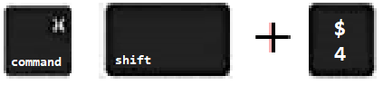
For the Mac
- hold down command + shift keys and press the 4 key
to get a screenshot of a selected area of the screen

- Use the mouse or touchpad to select the desired area of the screen you want to save
- use command+V to paste into the lab report

For Windows

- use Microsoft's Snipping Tool by holding down the
Windows and Shift keys and tapping the ‘S’ key
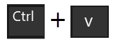
- Use the mouse or keypad to select the part of the screen you want to save
- use Ctrl+V to into the lab report
Capture the active window to the clipboard by holding down the Alt key and tapping the PrintScreen key. NOTE: some notebook computers require that you hold down a [Fn] key and Alt keys to activate the PrintScreen function. NOTE: Do not click PrintScreen without the Alt key. This would capture the entire screen which would make your program output difficult to see.
Use Ctrl+V to paste the clipboard into the lab report.
Place your screenshots here

